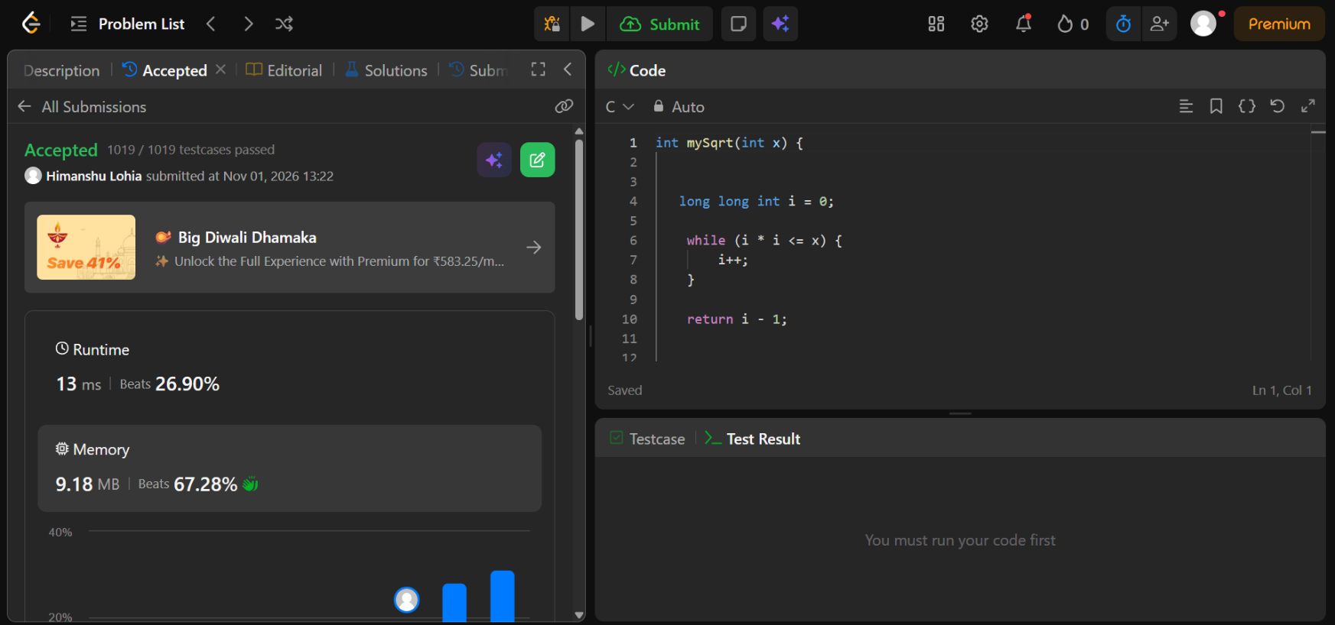
https://leetcode.com/problems/sqrtx/description/

int mySqrt(int x)

long long int i = 0;

while (i * i <= x) {
i++;
}

return i - 1;

}

